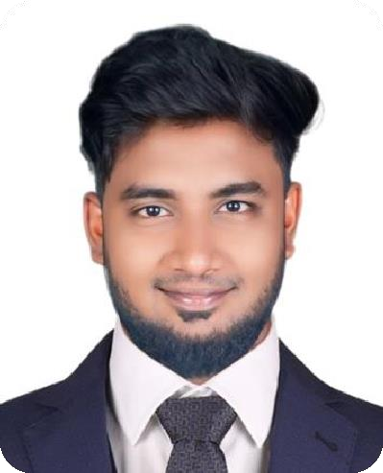 GOUTHAMAN MARAN

MBA GRADUATE

Looking forward for an opportunity to work in a challenging environment.
Where i can utilize my knowledge skills in contribution effectively to the
success of the organization and also for the improvement of my personal skills.

+971 505701086 gauthimaran3@gmail.com Dubai(UAE).

CORE SKILLS & KNOWLEDGE

WORK EXPERIENCE
- Advanced Ms Office
- Networking & Relationship Building
- Adaptability
- Creativity
- Team Work & Collaboration
- Finance & Accounting
- Team Management
- Marketing & Branding

LANGUAGES

2022-2026
Chennai India

2019-2022
Chennai India
FORTEMANAGEMENT SERVICES PVT.LTD.Chennai
DESIGNATION: Area Collection Manager (Debt recovery agent)
ROLES AND RESPONSIBILITIES:
  - Initiate contact with debtors via phone calls, emails, letters, or messages.
  - Handle disputes or complaints professionally.
  - Meet or exceed assigned recovery targets.
  - Provide documentation when requested by the debt or management.
  - Work closely with billing, legal, and customer service teams.
  - Verify the identity of the debtor and ensure privacy compliance

ICICI BANK,Chennai
DESIGNATION: Loan Recovery Agent
ROLES AND RESPONSIBILITIES:
  - Initiate contact with debtors via phone calls, emails, letters, or messages.
  - Discuss repayment options and timelines.
  - Verify the identity of the debtor and ensure privacy compliance
  - Maintain accurate and updated records of all communications and transactions
  - Work closely with billing, legal, and customer service teams.
  - Escalate unresolved cases for legal action if necessary.
  - Use tools and data bases to locate debtors who have changed addresses or contact information
Tamil English

EDUCATION
2017-2019 – 79%
MBA–Finance&Marketing SMVEC,Madagadipet, Puducherry

2014-2017-74%
BBA-General Achariya Arts&Science College, Villianur,Puducherry.

2014 - 77%
HSC-Commerce- Don Bosco Matric Hr.Sec.School, Puducherry,India

PERSONAL PROFILE

GOUTHAMAN S/O:MARAN.R
- 14-07-1997/28Yrs
- MALE
- HINDU
- INDIAN
- UNMARRIED

DECLARATION
I hereby declare that all the details furnished are true to my knowledge and I am looking for your kind acceptance of my application and opportunity to serve in your organization.
Your’s Faithfully

Gouthaman Maran

